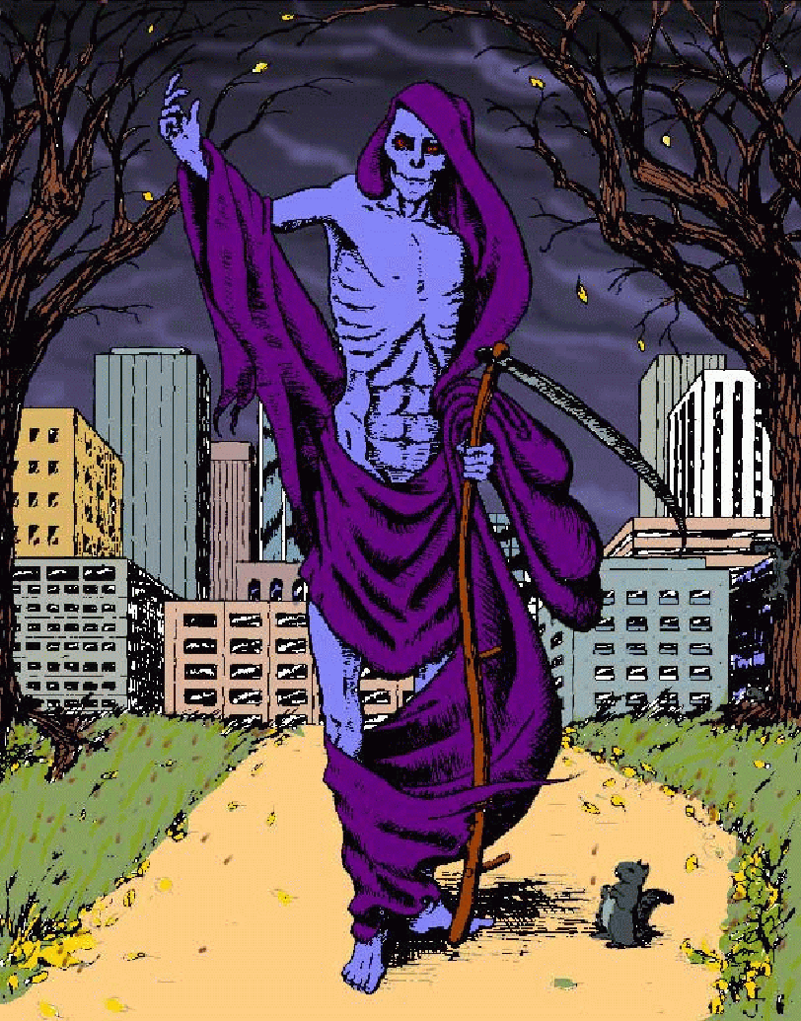 Anthropology 2U03 Plagues and People

Fall 2018

**Instructor:** Hendrik Poinar

**Email:** [poinarh@mcmaster.ca](mailto:poinarh@mcmaster.ca)

**Lecture:** Wednesday/Friday 9:30-10:30

**Tutorials:** TBD

**Office:** CNH 537

**Office Hours:** Wednesday 10:30-11:30

**Contents**

Course Description 3

Course Objectives 3

Required Materials and Texts 3

Class Format 3

Course Evaluation – Overview 3

Course Evaluation – Details 3

Assignment/Exam 1 (20%), due October 5th 3

Assignment/Exam 2 (20%), due November 16th 3

Guided Reading Questions (10%), due each week at tutorial start…… ……………….3

Tutorial Parcipation (10%) ………………………………………………………………….3

Final Exam (40%) TBD………………………………………………………………………3

Weekly Course Schedule and Required Readings 3

Week 1 (Dates) 3

Week 2 (Dates) 3

Week 3 (Dates) 4

Week 4 (Dates) 4

Week 5 (Dates) 4

Week 6 (Dates) 4

Week 7 (Dates) 5

Week 8 (Dates) 5

Week 9 (Dates) 5

Week 10 (Dates) 5

Week 11 (Dates) 6

Week 12 (Dates) 6

Week 13 (Dates) 6

Course Policies 7

Submission of Assignments 7

Grades 7

Late Assignments 7

Absences, Missed Work, Illness 7

Avenue to Learn 7

Turnitin.com 7

University Policies 8

Academic Integrity Statement 8

Academic Accommodation of Students with Disabilities 8

Religious, Indigenous and Spiritual Observances (RISO) 8

Faculty of Social Sciences E-mail Communication Policy 9

Privacy Protection 9

Course Modification 9

# Course Description

We live in an era obsessed with killer germs, epidemics and pandemics. There is a mounting sense of vulnerability as a growing list of pathogens becomes visible. Epidemics and plagues, however, are not new; they have influenced the course of human history for thousands of years.

This course considers the origins, antiquity, and impact of plagues on human societies from an anthropological, biological, evolutionary and biosocial perspective. It is structured around two, one-hour lectures and a one-hour tutorial.

# Course Objectives

The lectures begin with an exploration of definitions, models and general principles of infectious disease to establish frameworks for understanding plagues. We then discuss specific plagues, historic and contemporary, with a view to understanding why they emerge and evolve, how they are intimately linked to human behaviour, and how they transform societies. Dorothy Crawford’s (2007) book, *Deadly Companions: How Microbes Shaped our History* discusses how humans influence, and have been influenced by, some of the smallest forms of life on earth. Peter Washer’s (2010) book, *Emerging Infectious Diseases and Society*, takes up the problem of “plague” today. Paul Slacks (2012) book, Plague: A Very Short Introduction, talks specifically about the Black Death and the ramifications on medieval society. Marta Wayne and Ben Bolkers short introduction provides some of the basic biology of the pathogens we’ll discuss and some basics of epidemic modelling By the end of this course, you will:

* Understand the relationship between human behavior, environment and epidemics.
* Understand the etiology of major pandemics of the past and present.
* Appreciate the importance of studying historic plagues for understanding current and future epidemics.
* Understand the anthropological framework for interpreting the biosocial origins and consequences of epidemics.
* Understand the basic evolutionary relationships of pathogens
* improve your critical thinking skills

# Required Materials and Texts

Crawford, Dorothy H. (2007) *Deadly Companions: How Microbes Shaped our History*. Oxford: Oxford University Press.

Washer, Peter (2014) *Emerging Infectious Diseases and Society*. New York: Palgrave Macmillan.

Slack, Paul, (2012) *Plague: A Very Short Introduction*. Oxford: Oxford University Press.

Wayne, Marta and Bolker, Ben (2015) *Infectious Disease: A Very Short Introduction*. Oxford: Oxford University Press.

# Class Format

Two one-hour lectures and one, one-hour Tutorial.

# Course Evaluation – Overview

**Two (2) in-class exams (50 minutes each)**

* 1. **Friday, October 5th**: material from previous 4 weeks up to an including Wednesday the 3rd.
  2. **Friday November 16th**: material from October 15th to and including Wednesday November 14th.

Theses in-class exams evaluate your understanding of the course material. They will consist of varying combinations of multiple choice, short-answers (e.g. definitions, short explanations, comparisons, etc.) and essay questions on material from lectures, tutorials, films and readings.

2. **Tutorial participation**

Your TA will evaluate your contributions to the weekly tutorial sessions. It is not sufficient to attend; you must contribute to discussions and demonstrate that you have done the assigned reading.

3. **Guided Reading Questions (GRQ)**

Questions on the reading assigned for your tutorial will be posted each week on our Avenue website Friday night or Saturday morning. This will begin the week of September 17th. You are required to submit a 500-word answer (work alone) to **all three** of the posted questions (500 words ***TOTAL*** for all three – ***NOT*** 500 words per question!). To be eligible for the pass, you must submit the 500-word discussion each week in your tutorial at the beginning of class. **THERE ARE NO MAKEUPS FOR GRQs**. Please **print out** your answers label them with **your name, ID#, tutorial section (Friday 1-2) and the instructor’s name (i.e. Sam Price)**. Hand them in at the start of tutorial – not the end (they aren’t valid then). They are PASS/FAIL. We look for the major points/themes in your answers. We DO NOT grade your Shakespearean English. THEY CANNOT BE EMAILED, OR ELECTRONICALLY SUBMITTED, PAPER ONLY PLEASE.

4. **Final exam during examination period (2 hours)**

The final exam covers all the course material. It will consist of multiple choice, short-answers (e.g. definitions, short explanations, comparisons, etc.) and essay questions on material from lectures, tutorials, films and readings.

# Course Evaluation – Details

## Assignment/test/exam 1 (20%),

This first midterm will test you on the material covered in both lecture and tutorial up to that point. This exam will take place Friday October 5th.

## Assignment/test/exam 2 (20%),

This second midterm will ONLY cover the material covered in both lecture and tutorial taught *post* the first midterm and up to the last lecture prior to the second midterm. This exam will take place Friday November 16th.

**Guided Reading Questions (Tutorial) (10%)**, each week you’ll be responsible for answering a set of questions based on the readings in preparation for the tutorials.

**Participation (Tutorial) (10%).** Tutorial participation is mandatory, there are NO makeup tutorials. All material presented during tutorials are usable on all exams.

**Final Exam (40%)**. The final will cover the entire course material from both lecture and tutorials, however the bulk of the final will be based on the last portion of the course, post the second midterm.

# 

# Weekly Course Schedule and Required Readings

**LECTURE, READING AND TUTORIAL SCHEDULE**

|  |  |  |  |  |  |  |  |  |  |  |  |  |  |  |  |  |  |  |  |  |  |  |  |  |  |  |  |  |  |  |  |  |  |  |  |  |  |  |  |  |  |  |  |  |  |  |  |  |  |  |  |  |  |  |  |  |  |  |  |  |  |  |  |  |  |
| --- | --- | --- | --- | --- | --- | --- | --- | --- | --- | --- | --- | --- | --- | --- | --- | --- | --- | --- | --- | --- | --- | --- | --- | --- | --- | --- | --- | --- | --- | --- | --- | --- | --- | --- | --- | --- | --- | --- | --- | --- | --- | --- | --- | --- | --- | --- | --- | --- | --- | --- | --- | --- | --- | --- | --- | --- | --- | --- | --- | --- | --- | --- | --- | --- | --- |
| |  |  |  |  | | --- | --- | --- | --- | | **Week (#)** | **Lecture Topic** | **Reading** | **Tutorial** | | Sept 3rd (1) | Plagues and People Intro |  | No tutorials | | Sept 10 (2) | What is a Plague? | Slack, P Chp 1  Wayne/Bolker Chp 1  Crawford, Chp 1, 2 | Plague family feud! | | Sept 17 (3) | Plagues in History  The Black Death | Crawford, Chp 3 pp 75-81  Crawford pp 82-106  Slack, P Chp 2 | Will the Black Death rise again? Yes? No? Fight for your side! | | Sept 24 (4) | Emerging Disease | Crawford pp 184-204  Washer, Chp 1, 2  Wayne/Bolker Chp 2 | Fiction and Disease | | Oct 1 (5) | War and plague  *Exam #1 Oct 5th* | Crawford, Chp 6 pp 151-157  Slack, P Chp 3 | Synergy or causation networks | | October 8 | **NO CLASSES** | **Fall recess** | **NO TUTORIALS** | | Oct 15 (6) | The Speckled Monster | Crawford pp 106-124;161-179  Washer, ch 7 pp 143-147 | Bioterrorism | | Oct 22 (7) | The Forgotten Plague | Crawford pp 204-210  Washer pp 78-85, 98-107  Wayne/Bolker Chp 3 | Blame | | Oct 29(8) | The Secret Plague | Crawford pp 124-130; 189-191  Washer, ch 3 pp 45-61  Wayne/Bolker Chp 4 | HIV/AIDS | | Nov 5 (9) | The White Plague | Crawford pp 157-160, ch 8  Washer pp 25-26,57,162-68 | Public health and media | | Nov 12 (10) | *Exam #2 Nov 16th*  *FILM TBD* | *To be assigned* | Mad cows, modern plagues and superbugs | | Nov 19 (11) | The Fever Plague | Crawford pp 35-47  Washer, ch 5 (page 93!)  Wayne/Bolker Chp 6 | Malaria Wars | | Nov 26 (12) | The Hot Plague | Crawford pp 130-138,  Washer pp 26-27  Wayne/Bolker Chp 5 | Dirt, germs and the immune system | | Dec 3 (13) | Anthropology of Plague | Crawford, Conclusion  Washer, ch pp 159-168 | Q & A wrap-up | |  | Q & A |  |  | |  |

# Course Policies

## Submission of Assignments

SEE GRQ policy above.

## Grades

Grades will be based on the McMaster University grading scale:

| **MARK** | **GRADE** |
| --- | --- |
| 90-100 | A+ |
| 85-90 | A |
| 80-84 | A- |
| 77-79 | B+ |
| 73-76 | B |
| 70-72 | B- |
| 67-69 | C+ |
| 63-66 | C |
| 60-62 | C- |
| 57-59 | D+ |
| 53-56 | D |
| 50-52 | D- |
| 0-49 | F |

## Late Assignments

Late assignments are not accepted. Period. The GRQ’s are important preparation for each week’s tutorial and given the percentage of their worth, it isn’t economical to use your MSAF to ‘save’ you… think wisely.

## Absences, Missed Work, Illness

There are no make-up exams, unless of course you are ill and use your one MSAF form. You must see me (or email me) immediately (when you are able, of course), to set up a make-up time that is convenient. Questions used on make-up exams are drawn from a different pool of questions then those used in the regularly scheduled exams.

## Avenue to Learn

In this course we will be using Avenue to Learn. Students should be aware that, when they access the electronic components of this course, private information such as first and last names, user names for the McMaster e-mail accounts, and program affiliation may become apparent to all other students in the same course. The available information is dependent on the technology used. Continuation in this course will be deemed consent to this disclosure. If you have any questions or concerns about such disclosure please discuss this with the course instructor.

## Turnitin.com

In this course we will be using a web-based service (Turnitin.com) to reveal plagiarism. Students will be expected to submit their work electronically to Turnitin.com and in hard copy so that it can be checked for academic dishonesty. Students who do not wish to submit their work to Turnitin.com must still submit a copy to the instructor. No penalty will be assigned to a student who does not submit work to Turnitin.com. All submitted work is subject to normal verification that standards of academic integrity have been upheld (e.g., on-line search, etc.). To see the Turnitin.com Policy, please to go [www.mcmaster.ca/academicintegrity](http://www.mcmaster.ca/academicintegrity).

# University Policies

## Academic Integrity Statement

You are expected to exhibit honesty and use ethical behavior in all aspects of the learning process. Academic credentials you earn are rooted in principles of honesty and academic integrity.

Academic dishonesty is to knowingly act or fail to act in a way that results or could result in unearned academic credit or advantage. This behavior can result in serious consequences, e.g. the grade of zero on an assignment, loss of credit with a notation on the transcript (notation reads: “Grade of F assigned for academic dishonesty”), and/or suspension or expulsion from the university.

It is your responsibility to understand what constitutes academic dishonesty. For information on the various types of academic dishonesty please refer to the Academic Integrity Policy, located at [www.mcmaster.ca/academicintegrity](http://www.mcmaster.ca/academicintegrity).

The following illustrates only three forms of academic dishonesty:

1. Plagiarism, e.g. the submission of work that is not one’s own or for which credit has been obtained.
2. Improper collaboration in group work.
3. Copying or using unauthorized aids in tests and examinations.

## Academic Accommodation of Students with Disabilities

Students who require academic accommodation must contact Student Accessibility Services (SAS) to make arrangements with a Program Coordinator. Academic accommodations must be arranged for each term of study. Student Accessibility Services can be contacted by phone 905-525-9140 ext. 28652 or e-mail [sas@mcmaster.ca](mailto:sas@mcmaster.ca). For further information, consult McMaster University’s Policy for [Academic Accommodation of Students with Disabilities.](http://www.mcmaster.ca/policy/Students-AcademicStudies/AcademicAccommodation-StudentsWithDisabilities.pdf)

**Religious, Indigenous and Spiritual Observances (RISO)**

The University recognizes that, on occasion, the timing of a student’s religious, Indigenous, or spiritual observances and that of their academic obligations may conflict. In such cases, the University will provide reasonable academic accommodation for students that is consistent with the Ontario Human Rights Code.

Please review the [RISO information for students in the Faculty of Social Sciences](https://socialsciences.mcmaster.ca/current-students/riso) about how to request accommodation.

## Faculty of Social Sciences E-mail Communication Policy

Effective September 1, 2010, it is the policy of the Faculty of Social Sciences that all e-mail communication sent from students to instructors (including TAs), and from students to staff, must originate from the student’s own McMaster University e-mail account. This policy protects confidentiality and confirms the identity of the student. It is the student’s responsibility to ensure that communication is sent to the university from a McMaster account. If an instructor becomes aware that a communication has come from an alternate address, the instructor may not reply at his or her discretion.

**Privacy Protection**

In accordance with regulations set out by the Freedom of Information and Privacy Protection Act, the University will not allow return of graded materials by placing them in boxes in departmental offices or classrooms so that students may retrieve their papers themselves; tests and assignments must be returned directly to the student. Similarly, grades for assignments for courses may only be posted using the last 5 digits of the student number as the identifying data. The following possibilities exist for return of graded materials:

1. Direct return of materials to students in class;
2. Return of materials to students during office hours;
3. Students attach a stamped, self-addressed envelope with assignments for return by mail;
4. Submit/grade/return papers electronically.

Arrangements for the return of assignments from the options above will be finalized during the first class.

## Course Modification

The instructor and university reserve the right to modify elements of the course during the term. The university may change the dates and deadlines for any or all courses in extreme circumstances. If either type of modification becomes necessary, reasonable notice and communication with the students will be given with explanation and the opportunity to comment on changes. It is the responsibility of the student to check his/her McMaster email and course websites weekly during the term and to note any changes.